Assiut EGYPT |  | Mobile: +201096965145  E-mail:  drsalmasamir79@gmail.com | 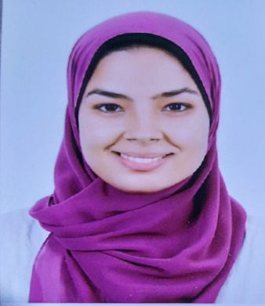
Salma Samir Mohamed Ahmed
Personal  Information | Nationality: Egyptian.  Date & Place of Birth: 29th of march 1996, Assiut, Egypt.  Marital Status: Married  Address: El mohafza street, Assiut
Education  Working  Courses  Skills  Activites and  interests | Bachelor degree in Veterinary medicine ( June 2019) with a general estimate of(Excellent )  Works as demonstrator at Microbiology and Immunology department at Faculty of Veterinary medicine Assiut university  IC3 course approved by Assiut university .  DNA Analysis techniques approved by Assiut university.  FDLC approved by Assiut university.  Languages: Arabic: Native English: Written and Spoken .  Computer:  Microsoft Word,Excel,Powerpoint,DataBase and Internet skills  Reading, and traveling.
1

